DIGITAL SIGNAL PROCESSING LABORATORY
EXPERIMENT NO. 5
Realization of IIR Filters Using Direct Form-I, Direct Form-II, Cascade and Parallel Structures Using MATLAB
Date of Experiment: 12 October 2026

Objectives
- To realize an IIR digital filter using Direct Form-I and Direct Form-II structures.
- To obtain cascade realization using second-order sections.
- To obtain parallel realization using partial-fraction expansion.
- To compare impulse responses and numerical errors of the different realizations.
- To plot the frequency response and pole-zero plot of the IIR filter.

Program Code
clc;
clear;
close all;
format short;

%% IIR Filter Coefficients
b = [0.0048 0.0193 0.0289 0.0193 0.0048];
a = [1 -2.3695 2.3140 -1.0547 0.1874];

N = 50;
x = [1 zeros(1,N-1)]; % Unit impulse
n = 0:N-1;

%% 1. Direct Form-I and Direct Form-II
y1 = filter(b,a,x);
y2 = filter(b,a,x);

%% 2. Cascade Realization
[sos,g] = tf2sos(b,a);
yc = g*x;

for k = 1:size(sos,1)
yc = filter(sos(k,1:3),sos(k,4:6),yc);
end

%% 3. Parallel Realization
[r,p,k] = residuez(b,a);
yp = filter(k,1,x);

for i = 1:length(r)
yp = yp + filter(r(i),[1 -p(i)],x);
end
yp = real(yp);

%% 4. Display Coefficients
disp('Numerator coefficients b ='); disp(b);
disp('Denominator coefficients a ='); disp(a);
disp('Second Order Sections (Cascade) ='); disp(sos);
disp('Cascade Gain ='); disp(g);
disp('Residues (Parallel) ='); disp(r);
disp('Poles (Parallel) ='); disp(p);
disp('Direct term ='); disp(k);

%% 5. Error and Percentage Deviation
E = [max(abs(y1-y2)); ...
max(abs(y1-yc)); ...
max(abs(y1-yp))];

D = E/max(abs(y1))*100;

Structure = {'DF-I'; 'DF-II'; 'Cascade'; 'Parallel'};
T = table(Structure, [0; E], [0; D], ...
'VariableNames', {'Structure','Maximum_Error','Deviation_percent'});

disp('Comparison Table:');
disp(T);

%% 6. Impulse Response Comparison
figure;
stem(n,y1,'filled'); hold on;
stem(n,y2,'--');
stem(n,yc,':','LineWidth',1.5);
stem(n,yp,'-.');
grid on;
xlabel('n');
ylabel('Amplitude');
title('Impulse Response of IIR Realizations');
legend('Direct Form-I','Direct Form-II','Cascade','Parallel');

%% 7. Error Plot
figure;
plot(n,abs(y1-y2),'--','LineWidth',1.2); hold on;
plot(n,abs(y1-yc),':','LineWidth',1.5);
plot(n,abs(y1-yp),'-.','LineWidth',1.2);
grid on;
xlabel('n');
ylabel('Absolute Error');
title('Numerical Error');
legend('DF-I vs DF-II','DF-I vs Cascade','DF-I vs Parallel');

%% 8. Frequency Response
figure;
freqz(b,a,1024);
title('Frequency Response of IIR Filter');

%% 9. Pole-Zero Plot
figure;
zplane(b,a);
title('Pole-Zero Plot');

MATLAB Output Screenshots
Figure 1: Impulse response comparison of Direct Form-I, Direct Form-II, cascade and parallel realizations.
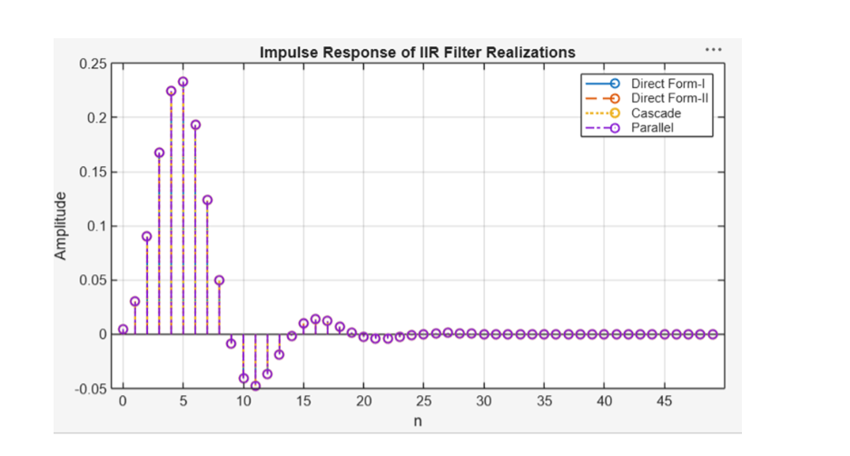
Figure 2: Reference impulse response of the IIR filter.
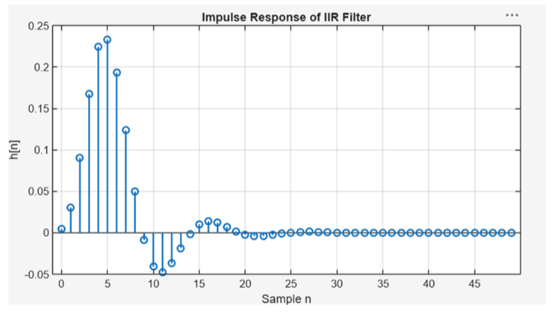

Figure 3: Numerical error between the filter realizations.
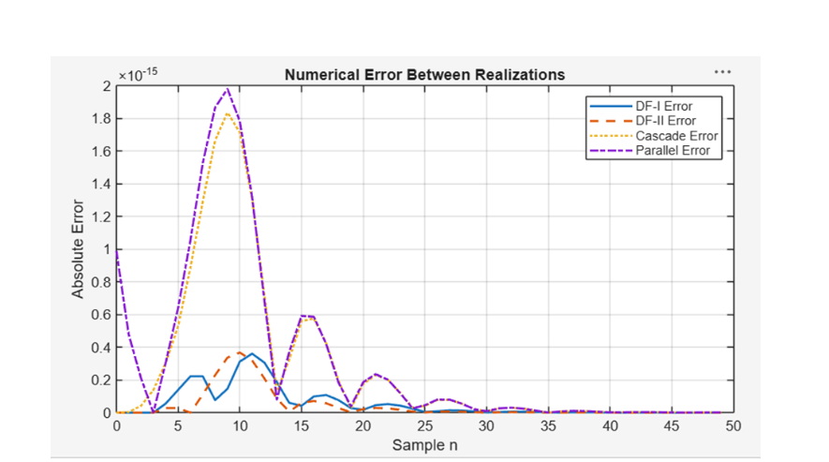
Figure 4: Frequency response of the IIR filter.
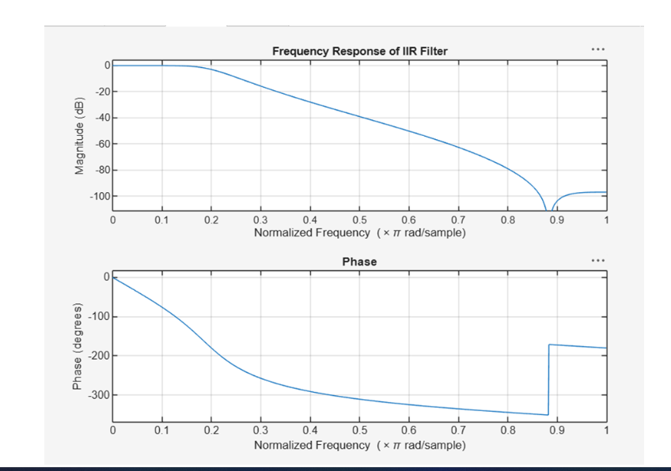

Figure 5: Pole-zero plot of the IIR filter.
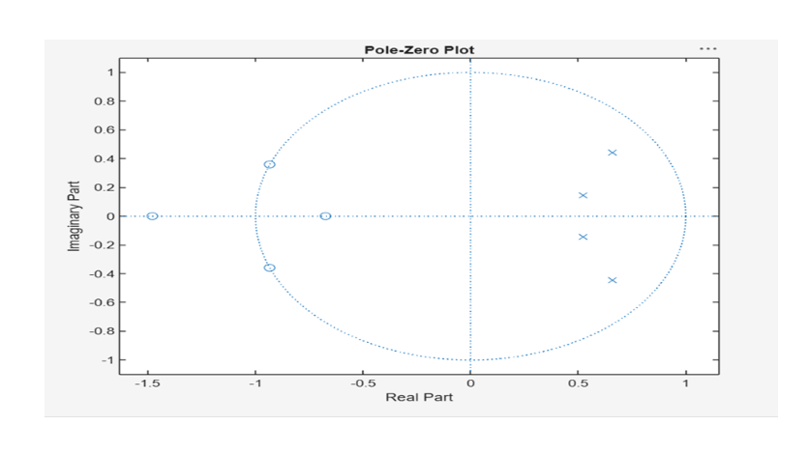

Output
The IIR filter was represented using Direct Form-I, Direct Form-II, cascade and parallel structures. The impulse responses, numerical errors, frequency response and pole-zero plot were obtained in MATLAB.

Done By
Lokesh A (192512293)
B.E. Electronics and Communication Engineering (ECE)

